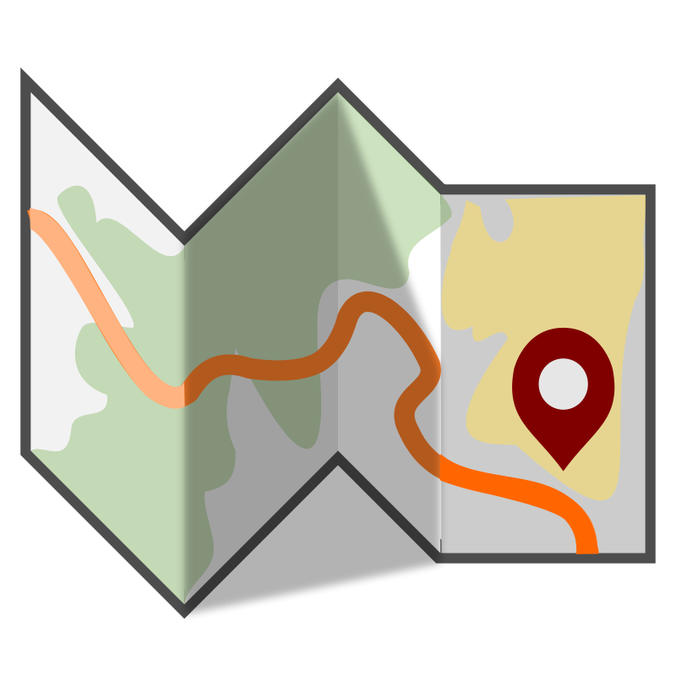
Name ______________________________

Date ______________________
Travel Brochure Book Report
March

Step One – You should select your fiction novel no later than __________________________. Remember, your book needs to be within your reading range and should be challenging enough to last you the majority of the month.

Which book did you pick? Title: _______________________ Author: ________________________

Step Two – Plan a reading schedule for your novel. Make sure you give yourself enough time to complete the project, not just the reading. Consider your timing last month when planning your reading for this month.
How many pages should you read each week to stay on track? ________

Step Three – Think about the setting, main events, and the main characters in your story. Imagine that you work for a travel agency and you have been asked to design a brochure to advertise an adventure like the one that took place in your book. You will create a brochure that would make people interested in going on the adventure. It should be informative and colorful.
Please feel free to use as much creativity as you’d like when creating this project, but remember, this is the student’s project. If you need help with supplies, please let me know as early as possible.

Here is what your travel brochure should include:
- Template:
Your brochure needs to be put together as a trifold, which resembles a travel brochure. It should be no smaller than an 8 ½ x 11inch paper. Feel free to get creative and use materials other than paper, crayons and colored pencils. The elements required below should be included in your brochure.
- Brochure cover/Illustration:
Design a cover that appeals to people. The cover should include the destination (title of the book), the travel guide’s name (author), and the student’s name. It should also include a hand-drawn illustration or graphic that relates to the story in a significant way. You might add a sentence or two to entice travelers to read your brochure. Illustrate the front flap with one or two of the main attractions of this place.
Format:
Plan the inside of the brochure before you begin writing or drawing.

Inside Fold #1 (Setting):
Discuss the setting of the story in a way that entices readers. If there is more than one setting in your novel, choose the most interesting one. What makes this place appealing? What special features does your location have? Make sure to use vivid language (ie: lush gardens, glistening water etc). Use 2-3 pieces of evidence with a page number of where you found it in the text. Illustrate a picture of the setting.
Inside Fold #2 (Things to do/Attractions):
Write about the attractions you might see or things you can do at your location. Write reasons that travelers would want to visit each attraction. If there is not a lot to see or do in this setting, be creative and think about how you could make this place sound appealing to tourists. (think about places your characters visit, or things they do) Include a hand drawn illustration of one of the attractions discussed.

Inside Fold #3 (Main Characters):
Introduce and discuss at least two “celebrities/ famous people” you might meet there (main characters from your novel). Include character traits, physical traits, talents etc of your character. What makes them special? Include 2-3 pieces of evidence with the page number from the text. There should be an illustration for each character.

Back:
On the back panel, write 3-5 sentences to provide any additional information that might persuade travelers to visit. Also, explain interesting events from the book that took place in this setting. At the bottom, write, “For additional information on (name of place), contact (your name)”

Step Four - You will be presenting your brochure/selling your location to your classmates on the day it is due.

Grading: I will be using this scoring guide to determine your grade (worth 100 points). Make sure not to lose this sheet - you must turn it in with your brochure!!
 | 5 | 4 | 3 | 2 | 1 | 0
Brochure template is used and project is put together in an organized way. 10pts
Illustrations are colored and project has a pleasant overall appearance. 10pts
Uses correct spelling, grammar, and punctuation throughout. 10pts
Includes title, author, and student name on the cover. 10pts
Includes quality description of setting with illustrations and evidence (2-3). 10pts
Includes attractions/places to visit with illustration. 10pts
Includes quality descriptions of 2 main characters with illustration and evidence (2-3). 10pts
Includes additional information/ reader’s recommendations. 10pts
Daily reading (as demonstrated by reading log). 20pts
Total Points (out of 100)
Due Date: Friday, March 27, 2015

Parents,
Please acknowledge below that you have read over these instructions with your child, and you are aware of the novel they are choosing to read for the month of March
Thank you!

Parent Signature Date
Date | Number of pages read | Current Page | Signature (verifying 30 minutes read)
3/2
3/3
3/4
3/5
3/6-3/8
3/9
3/10
3/11
3/12
3/13-3/15
3/16
3/17
3/18
3/19
3/20-3/22
3/23
3/24
3/25
3/26
3/27 | PROJECT | AND AR TEST | DUE
Daily Reading Log

*You need to be reading every night. When the novel is finished, you can include your work time on your project as part of your reading time, but must still get a signature. The log should be entirely filled out each night by the student.

